Requirement engineering Exercise – the ATM System

- Problem Description

An Automatic Teller Machine (ATM) is a computer based machine, connected to a network, that offers, as basic functions to users, access to bank account (balance, bank transfers) and retrieval of money.

- Stakeholders
User (end user who retrieves money, do bank transfer, check balance)
Maintenance person from bank (charges the money, maintains printer (ink, paper), gets retrieved cards)
Security auditor from credit card circuit (accepts or not the system to be connected with credit card circuit)
Security administrator (monitors security issues on ATM)
IT administrator (installs patches of the application, maintains platform (updates to OS, ..)
Link with Bloomberg for exchange rates NO (the computation of debit for foreign accounts is not done in ATM, but by mother bank in back end) NO this is an interface

CEO of bank (logo of bank should be shown …
(advertise other financial products)
CTO of bank (buys the system) (less than somuch Euros for the project)
Developers (nice development environment Java and not C.. ) , analysts (

- Context diagram and interfaces
1-a Define the context diagram of the application

We consider ONE atm (not the whole ATM circuit)

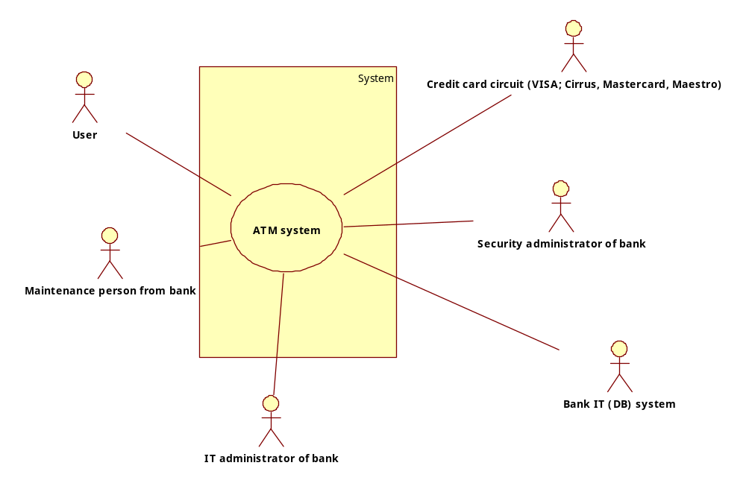

1-b Describe the interfaces of the application (to person)

Interfaces
With User :
Physical: Screen, keyboard, printer, card reader, cash dispenser (card and cash are physical objects exchanged between user and system)
Logical: GUi with screenshots for authorization, retrieval, balance, bank transfer

With maintenance person
Physical: Screen, keyboard, cash dispenser, card reader
Logical: GUI for authorization, monitoring status, loading money, opening/closing card reader, opening/closing cash dispenser

With IT administrator
Physical: Screen, keyboard
Logical: GUI for authorization, monitoring IT status, upgrade application and other platform software

With security administrator
Physical: Screen, keyboard
..

With IT administrator

1-c Describe the interfaces of the application (to other systems/devices)

With bank IT system
Physical: internet link
secure layer on top (cryptography, https ..)
Logical: functions that the Bank IT system provides to ATM system, and that ATM system requires (calls) to Bank IT system: verify card id, verify card password, verify amount request , debit amount to account (possibly refer the documentation describing the functions provided by library )

With credit card system
Physical: internet link
secure layer on top (cryptography, https ..)
Logical: verify card id, verify card password, verify amount request , debit amount to account

- User requirements.
2-a Define the user requirements, notably using a table with functional and non functional requirements.

Requirement ID | Description
R1 | Retrieve money yellow = high level, end user function
R2 | Check balance
R3 | Do bank transfer
R4 | Print receipt
R5 | Request ink splash on cash (in case of attack)
R6 | Communicate amount of cash added
R7 | Send Alarm when paper is low/ over
R8 | Send Alarm when ink is low/ finished
R9 | Send Alarm when cash is low/over
R10 | Change status of ATM when cash is over (cash dispensing not available) (better in state machine description)
R11 | Hold card
R12 | Read card
R13 | Verify PIN
R14 | Verify card (stolen, invalid for time)
R15 | Dispense cash
R16 | Ask PIN
R17 | Ask amount
R18 | Verify if amount(x) is available on account(y)
R19 | Compute account c attached to card r
R20 | Deduce a from account c
R21 | Eject card
 | Keep track of money available, money dispensed , money collected back (trace)
 | Monitor time between cash offered and cash retrieved by user
 | Monitor time between card returned and card taken
 | Monitor security related data and functions (number of attempts for PIN, number of attempts per card )
 | Monitor status of machine
NFR1 | The GUI should be user friendly - ambiguous non testable  Given n users with less than 1 year experience in using computers or mobile phones, they should be able to complete Function Rx in less than y seconds, without any help or tutoring  or  Function Rx should be completed with less than x choices (mouse clicks)
The system should be efficient ambiguous, non testable
Function R1 shall be performed in less than 1 second - ok, testable
 | Function R2 should be performed in less than 10 sec

2b GLOSSARY

Card = debit card or credit card

Debit Card = Plastic card, with number, typically attached to a bank, a customer and account
Credit Card = Plastic card, with number, typically attached to credit circuit (Visa, UnionPay, ..)
Account = credentials for accessing a service (username password)
Customer = customer description (name, address, ..)
Account = virtual deposit of money, where money can added or subtracted. Typically attached to a customer

Data absolutely avoid - too generic
System
Function

2C (extended) Glossary using class diagram
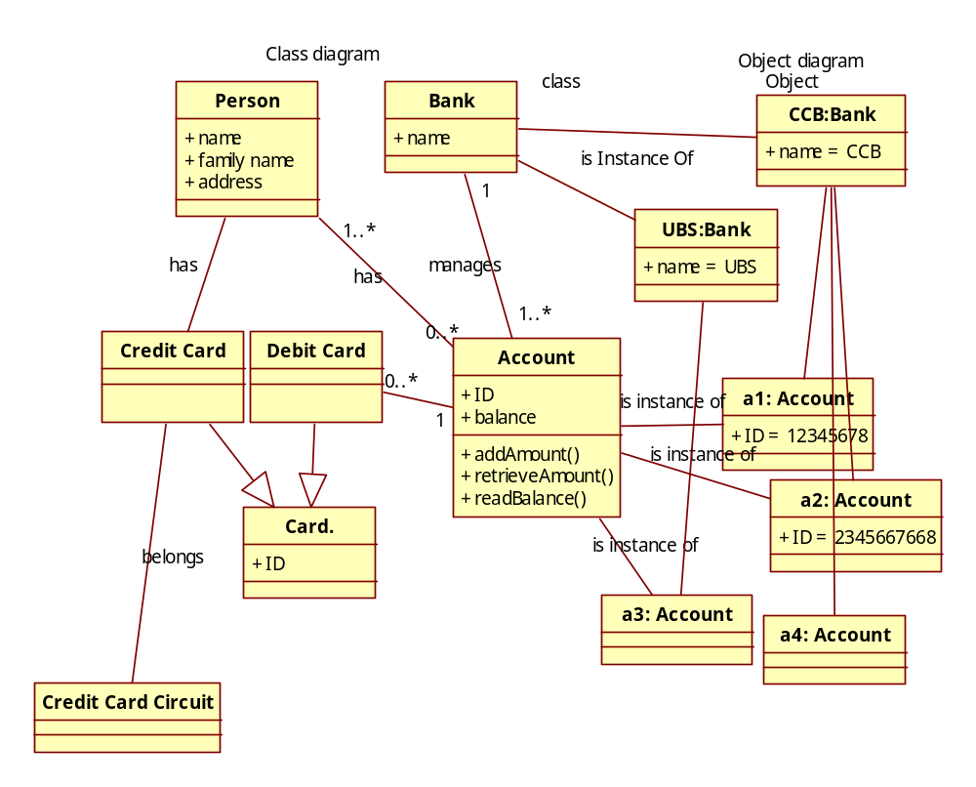
2-b Define the user requirements. As an alternative to the technique above describe each requirement with the following form (from 03_requirements slides)

Name | R7 Verify if amount a is available on account c
Description | verify that account c contains at least amount a (or c.balance > a)
Input | Account number c  Amount requested a
Output | True or false
Action | Call same function on information system of bank

2-c Define scenarios of use with the following template (from heating control system)

Scenario name  S1, retrieve money, requested amount given | General description
Step | Description | Requirement ID
1 | Read card r | R12
1A | Verify card (stolen, ..) | R14
2 | Ask PIN | R16
3 | Verify PIN | R13
4 | Ask amount | R17
5 | Read amount a
6 | Compute account c attached to card r | R19
7 | Verify if amount a is available on account c | R18
8 | Dispense cash a | R15
9 | Deduce a from account c | R20
10 | Print receipt | R4
11 | Eject card | R21

Scenario name  S5, retrieve money, card invalid | General description
Step | Description | Requirement ID
1 | Read card r | R12
2 | Verify card valid | R14
3 | Eject card | R21

S2 check balance
S3 bank transfer
S4, retrieve money, amount requested not available
S5, retrieve money, card invalid

High level function R1 can instantiate scenarios S1, S4, S5
High level function R2 can instantiate scenarios S2, ..

2-d Define the use case diagram

2-e Define the sequence diagrams for some specific scenarios

